**TEKHACK 2021**

Domain: AI

Team Name: DARK Coders

Project Name: Covaccine Bot

Team Members: D Deepak

K Kshiraj

G Rishi

D Abhinay

Project Description

Step 1

We have created ibm cloud account https://cloud.ibm.com/login

Step 2

We created services to create our bot.

Created service - Watson assistant

Step 3

We have launched our assistant

Step 4

In assistant we created skill using dialog.

Step 5

In dialog skill, we created Intent which

takes user input

Later created Entities which finds key words from the user inputs.

Step 6

Later we created dialogs by using intents n entities for bot reply

Step 7

Bot checks for the entities key words and reply to user

Step 8

We add this created skill to our assistant

In create assistant

Step 9

Give name to assistant & select the created skill dialog

Step 10

Integrate this skill in view mode

Here you can view your bot & and you will get shareable public link.

Covacine Bot Preview

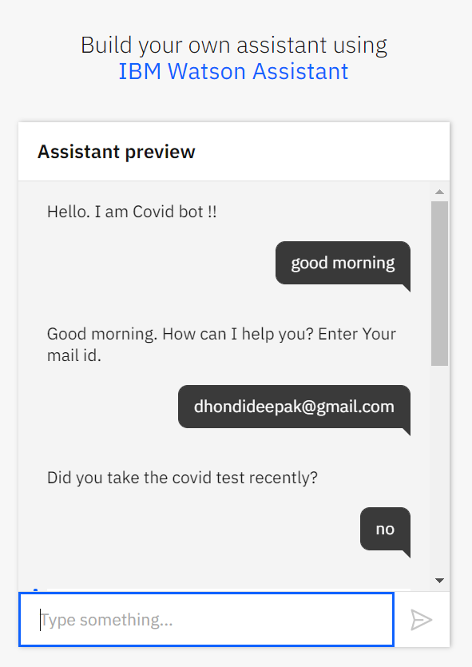 This is our bot

It take input greeting & mail id

It asks you have you gone with

COVID test.

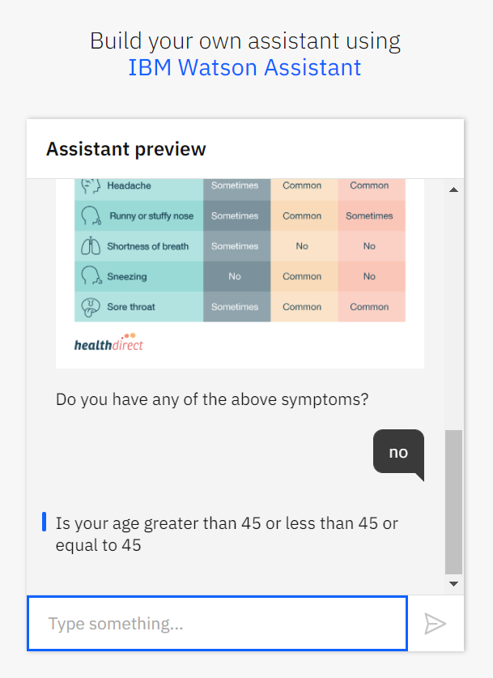

It displays the list of COVID symptoms.

We need to give input yes or no

Later it will check for the age.

You are eligible for vaccine if your age is >= 45

It will ask do you what to take vaccine and in government hospital or private hospital.

Later it displays the list of hospitals

We need to select the hospital for list

Finally it will send to appointment mail for vaccine to your mail id.

If your age is less than 45, it displays you are not eligible for vaccine.

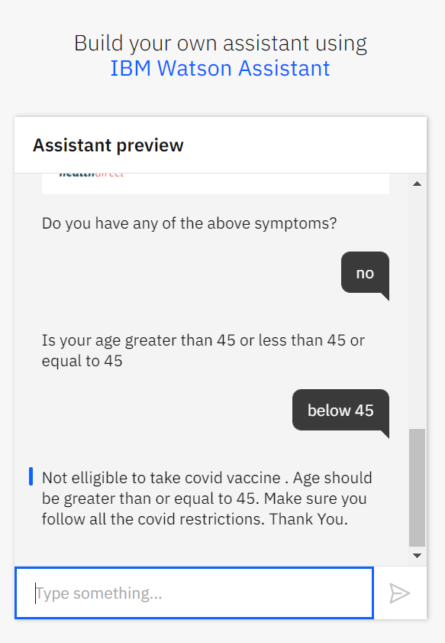 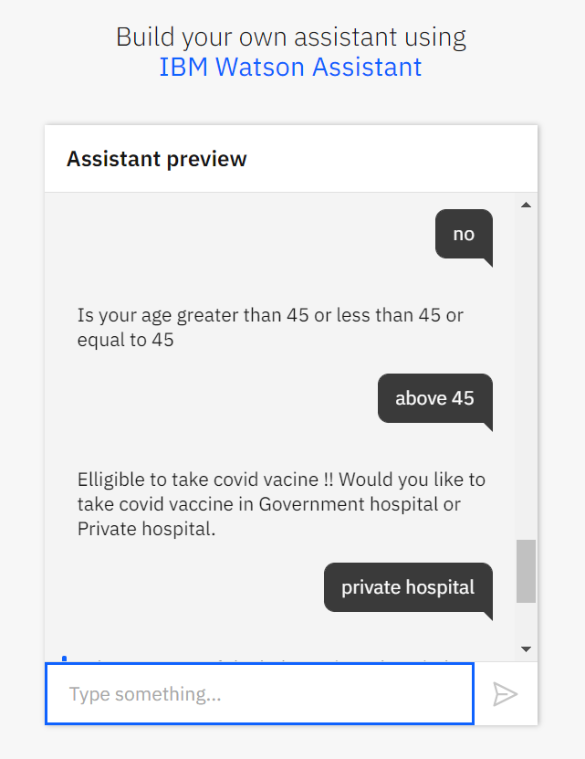 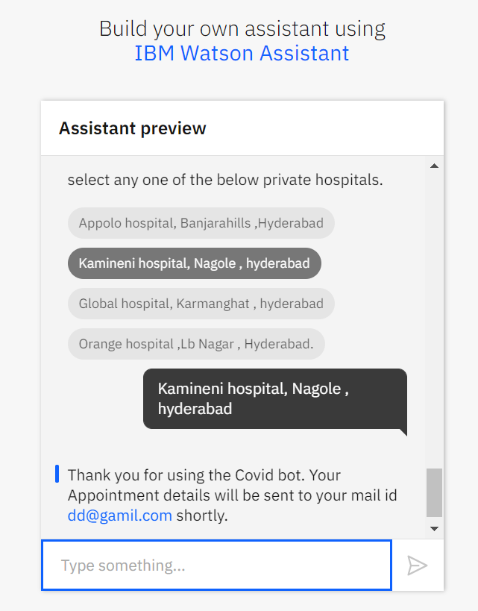

Thank You